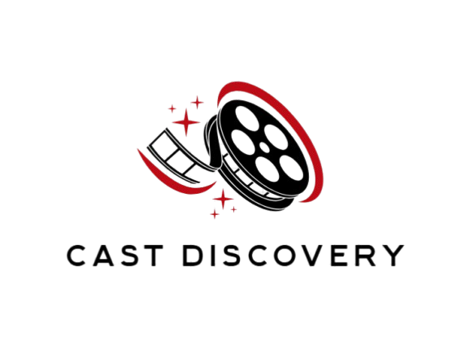

Team:

**Farah Al-Omari**

**Yahya snedawi**

Cast Discovery is a platform that connects emerging talents in the dramatic arts with organizations seeking fresh performers. We also aim to build a supportive community where artists can share experiences and collaborate. Together, we empower new talent and enrich the dramatic arts field!

**In our project the website consisted of several key pages:**

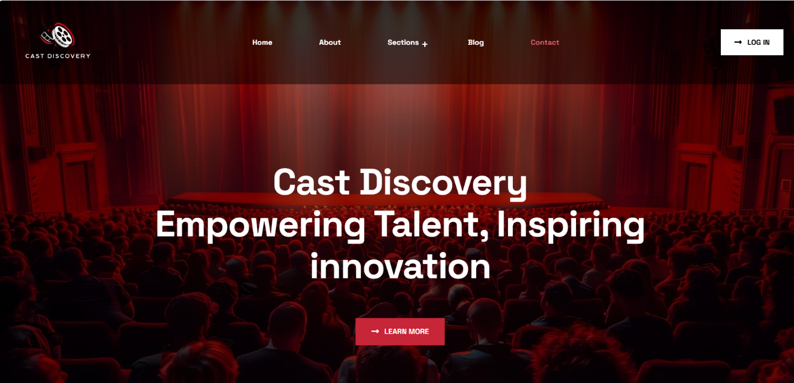**Home page**

This webpage is a clean and modern landing page for Cast Discovery, focused on attracting and empowering talent in the creative industries. The strong use of theatrical imagery and bold, inviting text demonstrates the platform’s emphasis on artistic talent, innovation, and community building.

**Title**: Cast Discovery - Empowering Talent, Inspiring Innovation

**Main Header:**

"Cast Discovery" is prominently displayed at the top of the page in bold, indicating the brand name. The phrase "Empowering Talent, Inspiring Innovation" serves as the company's tagline, reflecting its mission to support creativity and innovation in talent discovery, possibly for film, TV, or theater.

**Background:**

The background features an image of a theater stage with a red curtain, seen from the audience's perspective. This visual reinforces the focus on entertainment and showcases the setting where talent, such as actors or performers, may be highlighted.

**Navigation Bar:**

The navigation bar is at the top of the page, featuring the following sections:

**Home:** takes users back to the main homepage.

**About:** Provides information about the company's mission, goals, and services.

**Sections:** contain our additional resources such as casting opportunities, talent directories, or industry news.

**Blog:** A place where users can upload posts.

**Contact**: A section for reaching out to the company for inquiries.

**Log-In Option:**

In the upper right corner, there is a "Log In" button, allowing registered users to access their accounts.

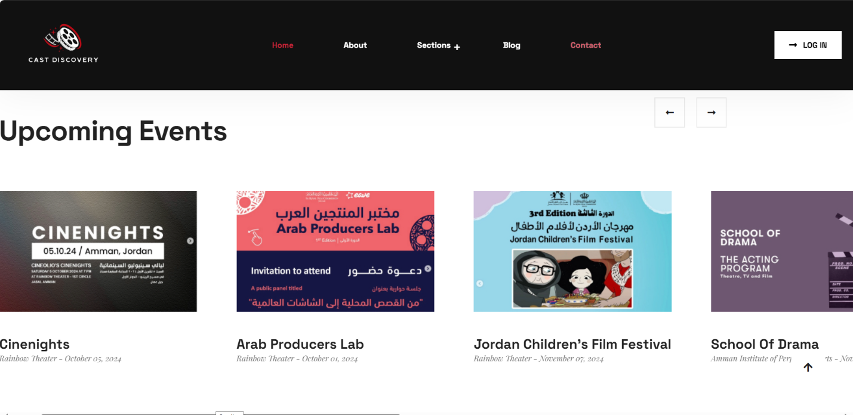**Main Section (Upcoming Events):**

This section highlights several upcoming events related to cinema and drama in Jordan and the Arab region. The events are presented with images, titles, locations, and dates.

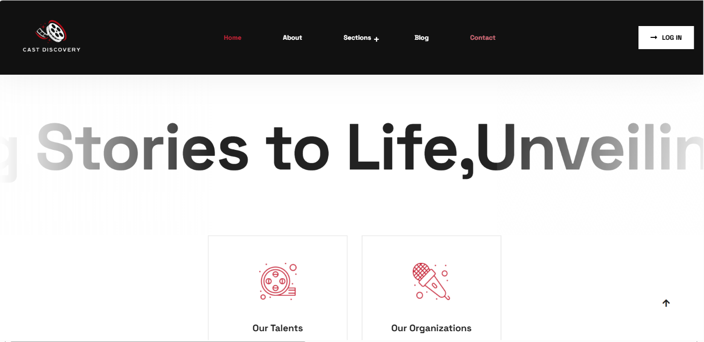**Banner Text**: A large banner with the text “Stories to Life, unveiling …” partially visible, suggesting this is the platform's core mission statement.

* + The slogan suggests that Cast Discovery is focused on storytelling and bringing creative works to life, perhaps in film, media, or performance arts.

**Two Main Sections Below the Banner:**

* **Our Talents**: Represented with a simple, red icon of a movie reel. This section likely leads to a page or section showcasing the talents (actors, filmmakers, or creators) associated with Cast Discovery.
* **Our organizations**: Depicted with a red microphone icon. This section likely leads to details about partner organizations or companies within the creative arts industry that are part of Cast Discovery’s network.

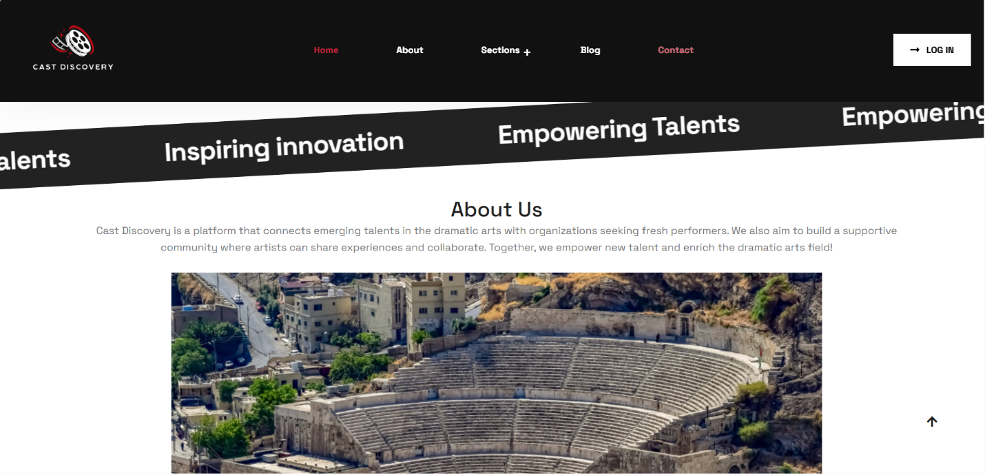

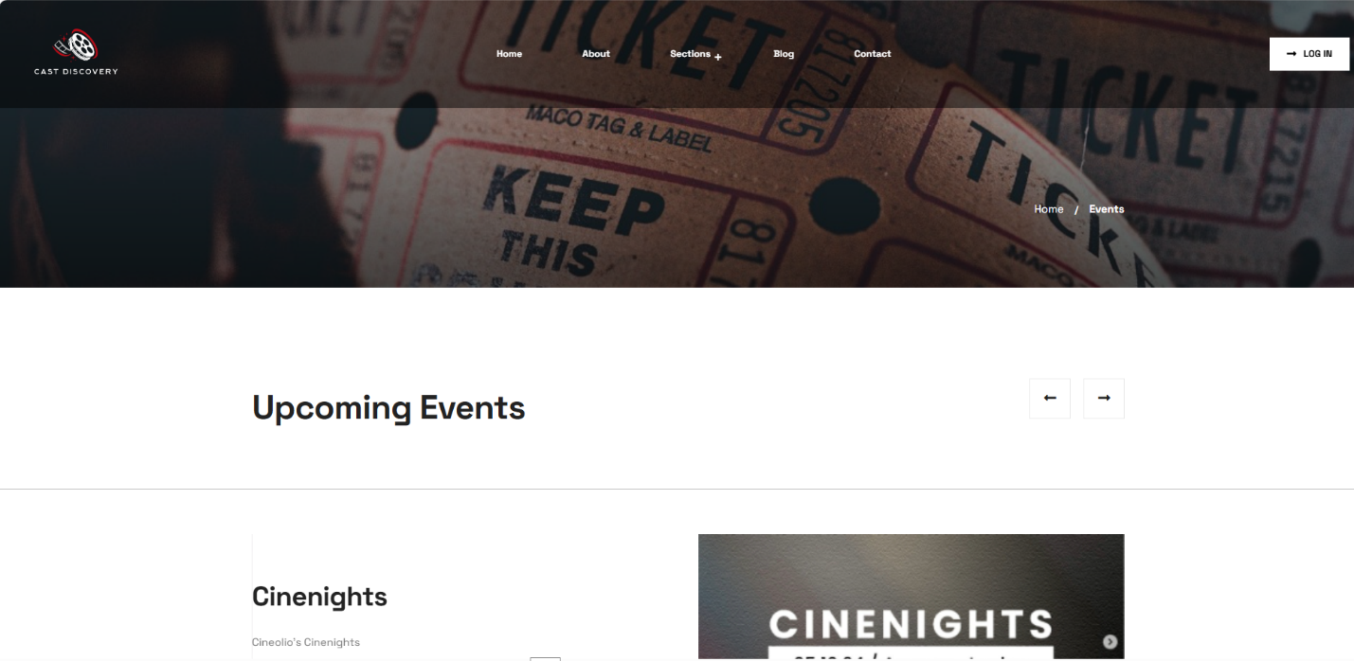

**Events page:**

Contain more details about the events and contain booking information.

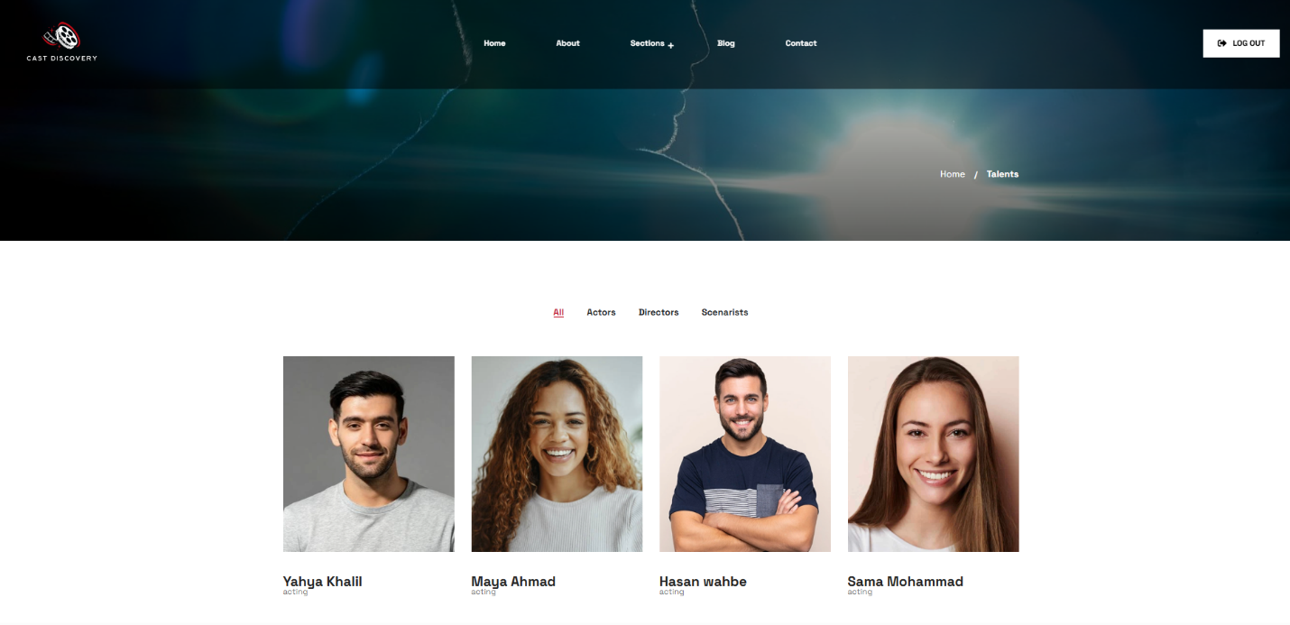

**Talent’s page:**

**Main Content:**

* **Breadcrumb Navigation**: Provides a trail to track the current page location (Home > Talents).
* **Filter Options**: Visitors can filter talents based on their roles (actors, directors, screenwriters).
* **Talent Cards**:
  + Each talent is represented by a card, containing:
    - Headshot/photo
    - Name
    - Role/Profession
    - (In the example, all are labeled as "acting.")

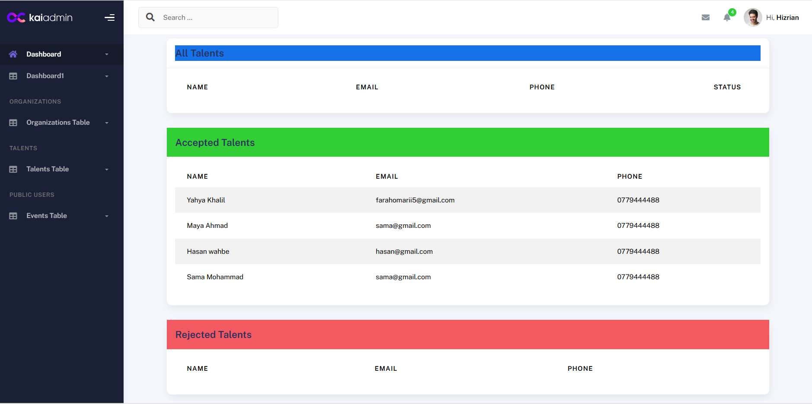

**Talent’s Dashboard**

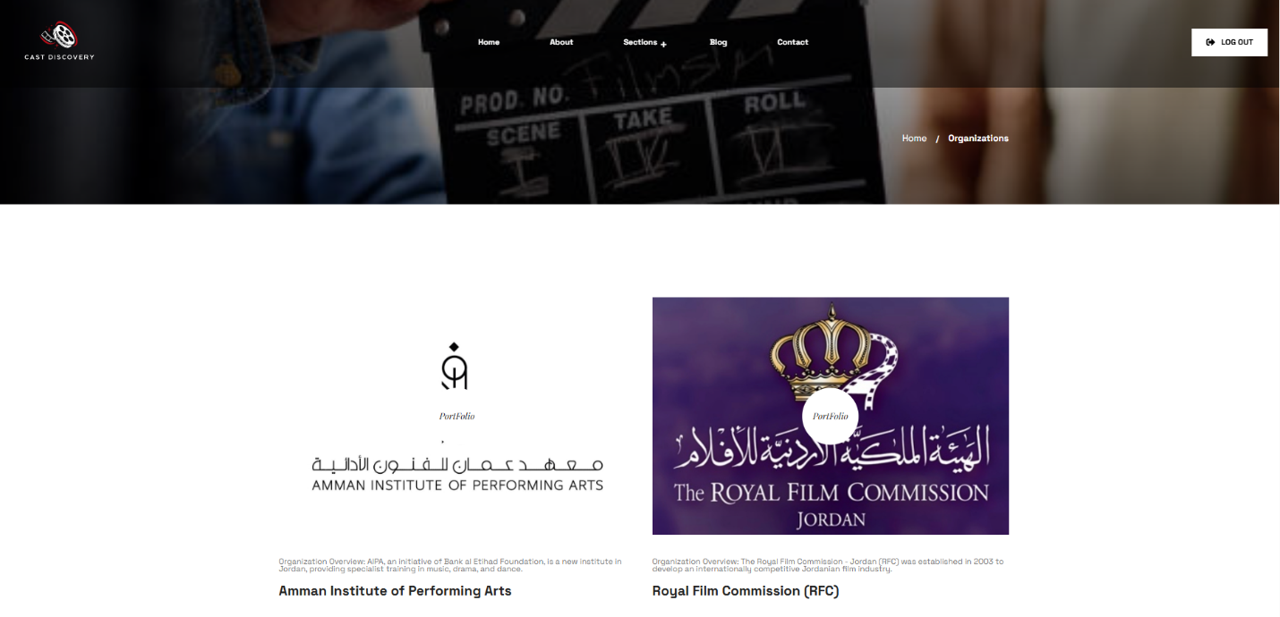

**Organizations page:**

**Main Content:**

* **Organization Display:**
  + The page features two key organizations relevant to performing arts and film production:
    1. **Amman Institute of Performing Arts (AIPA)**
    2. **Royal Film Commission (RFC)**
  + Each organization is presented with:
    1. A logo for immediate brand recognition.
    2. A description providing insight into the organization’s mission, goals, and background.

Organizations dashboard

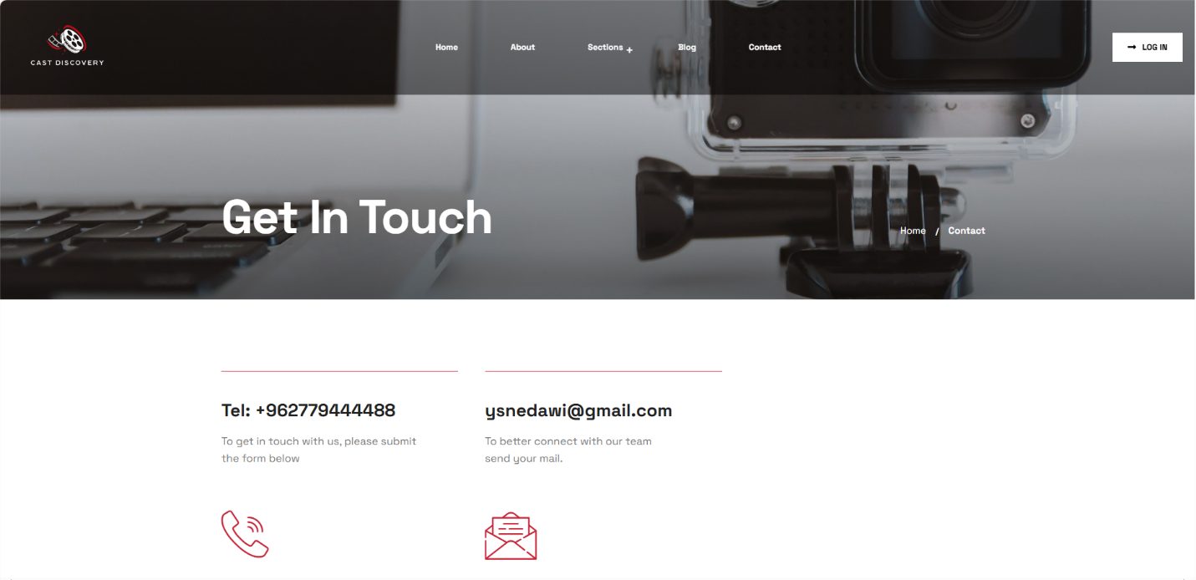

**Main Content:**

* **Contact Information Display:**
  + The page prominently features two methods of contacting the team at Cast Discovery:
    - A phone number for direct calls.
    - An email address for written correspondence.
  + Icons enhance the clarity of contact options, improving user interaction and making it easier for users to identify the type of contact information.

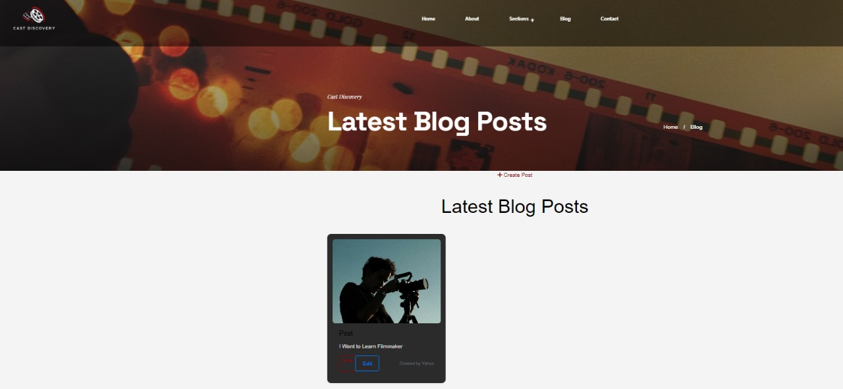

**Blog Posts Section**

The main content area showcases the latest blog posts by the platform's users. Each post is neatly displayed within a blog post card